CS Senior Project – Weekly Progress Report
Student Name: Moeez Malik
Project Title: Automated Business Decision Engine
Week of April 17
Report Date: April 17, 2026

Goals for This Week
What did you plan to accomplish this week? Be specific. Refer to your developer work plan.
- Finalize Deliver Checkpoint 3 presentation in class
- Begin Checkpoint 4 finalization tasks
- Conduct structured UI refinement pass focused on consistency and production-level stability
- Standardize layout and table formatting across pages
- Improve explanation readability
- Unify error message design
- Add processing feedback for large uploads
- Complete the "history" view that lists previous evaluation runs stored in SQLite
- Do end-to-end testing and write a final checklist of behaviors to verify
- Work Completed This Week
What you actually worked on. Include technical details where relevant.
Features implemented:
- Completed UI refinement pass with modern styling (gradients, shadows, consistent colors)
- Standardized layout across Upload, Results, Rules, and History pages
- Added processing feedback showing runtime metrics (milliseconds, records/second)
- Completed History view displaying all past evaluation runs with timestamps and performance data
- Added Export button to History page for each run
Research completed:
- Reviewed UI/UX best practices for consistent error message design
- Studied end-to-end testing methodologies
Design work:
- Unified error message design using red alert boxes with clear formatting
- Improved explanation readability with styled explanation-box component
- Created consistent classification color scheme (Red=High, Yellow=Medium, Green=Low)
Testing performed:
- End-to-end testing of all user flows documented in docs/END_TO_END_TESTING.md
- Tested UI behavior with 10,000-row dataset - pagination works smoothly
- Verified all 60 unit tests passing
- Created final verification checklist in docs/FINAL_CHECKLIST.md
Other progress:
- Created docs/TESTING.md with test execution instructions
- Created docs/REFACTORING_DEMO.md showing before/after code structure
- Added null values test file for error handling demonstration

Evidence of Progress
GitHub commits / repo link: https://github.com/moeezislammalik/automated-business-decision-engine
Screenshots / demos (next page)

Page Interface (as of Checkpoint 3)
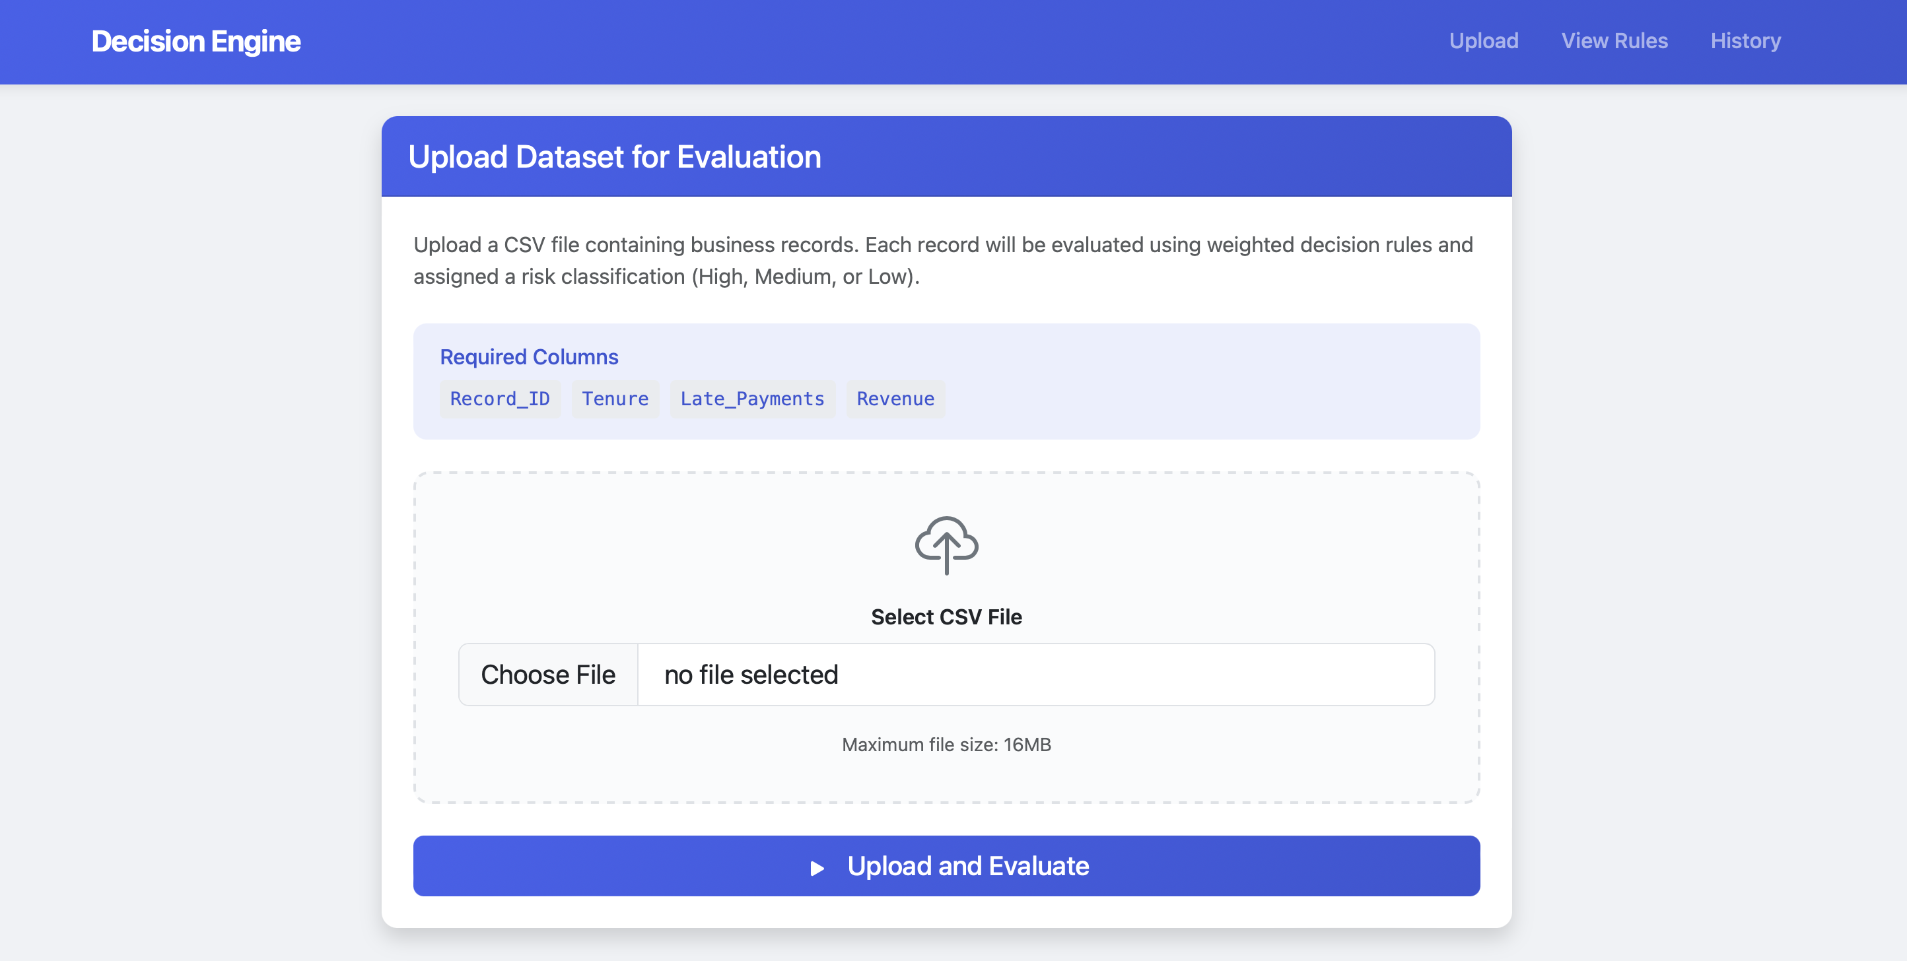
Results dashboard:
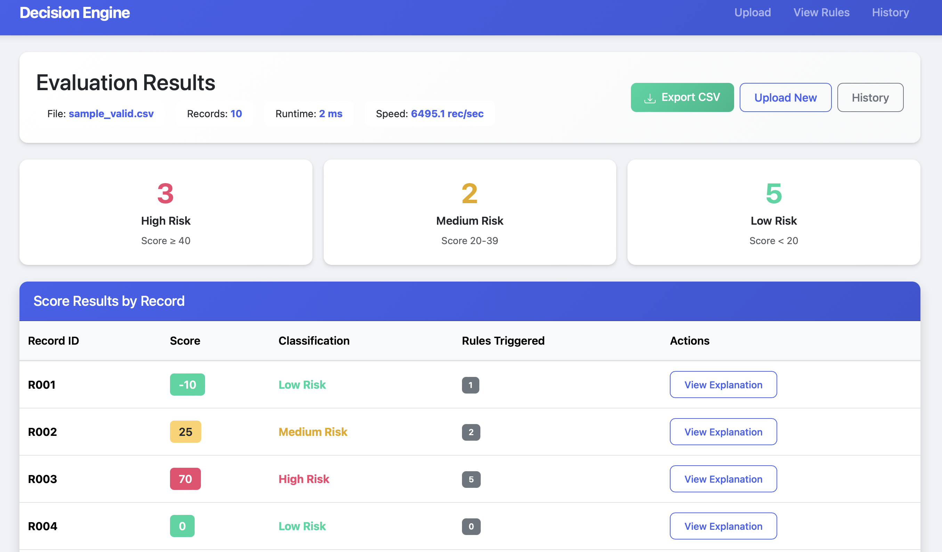

Classification Card:
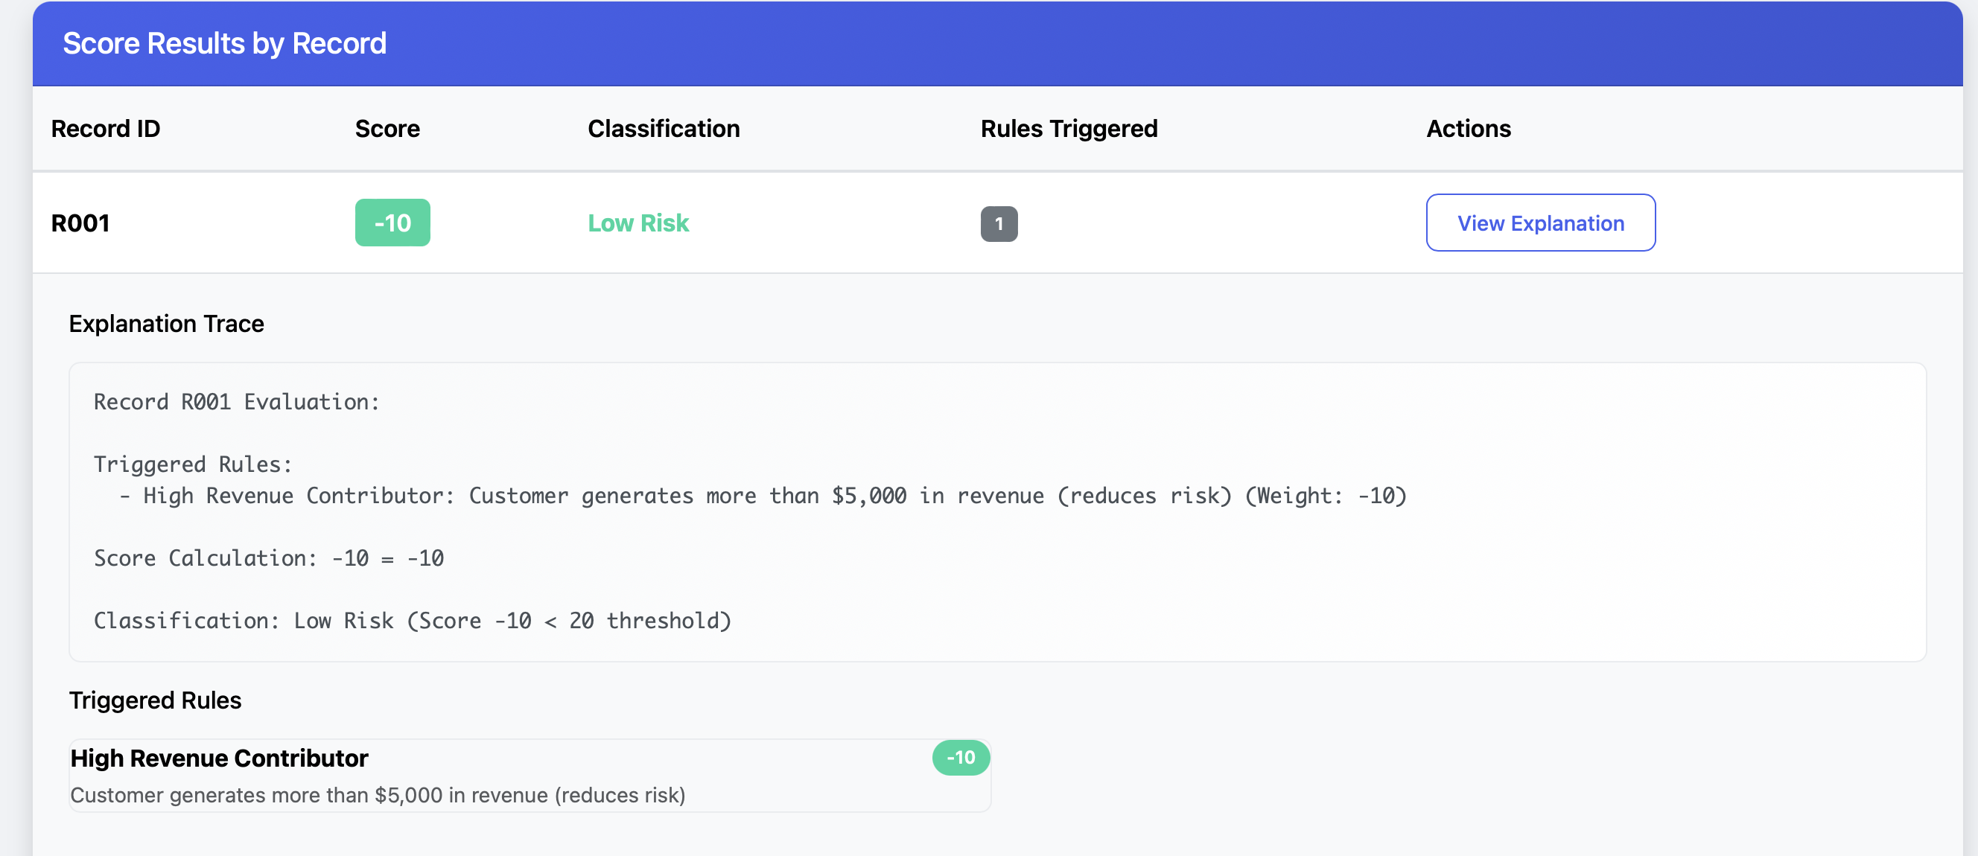
Performance Metrics:
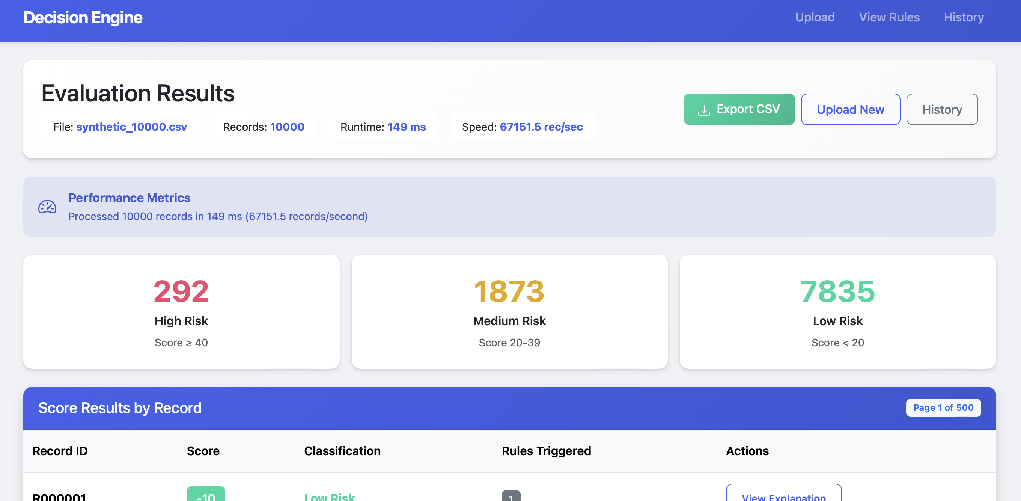
Pagination:
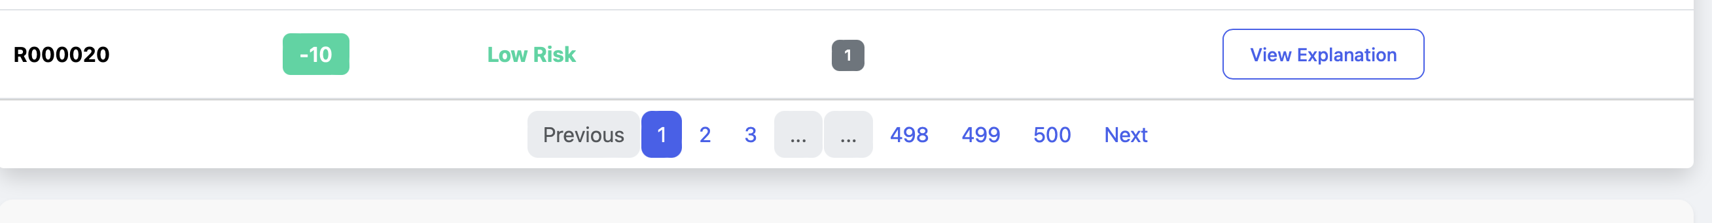

Test Validation
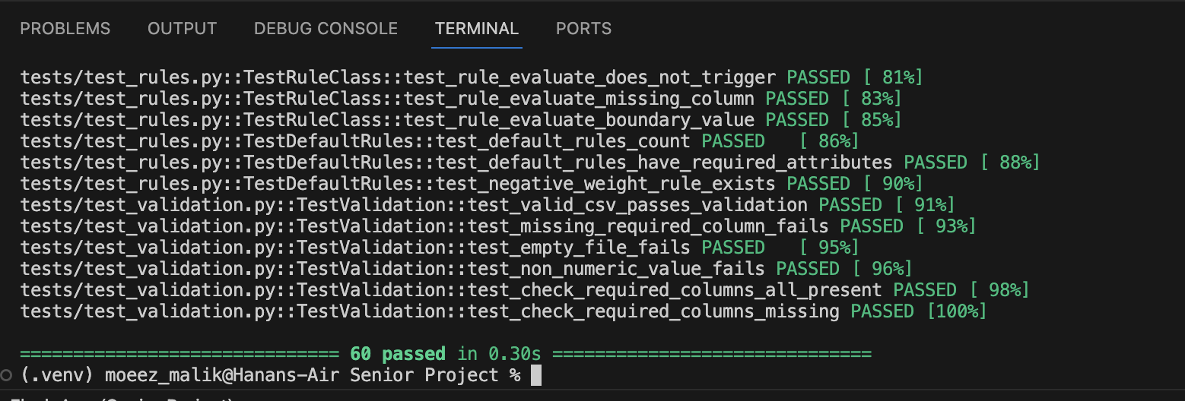
Before test files with Evaluation History page:
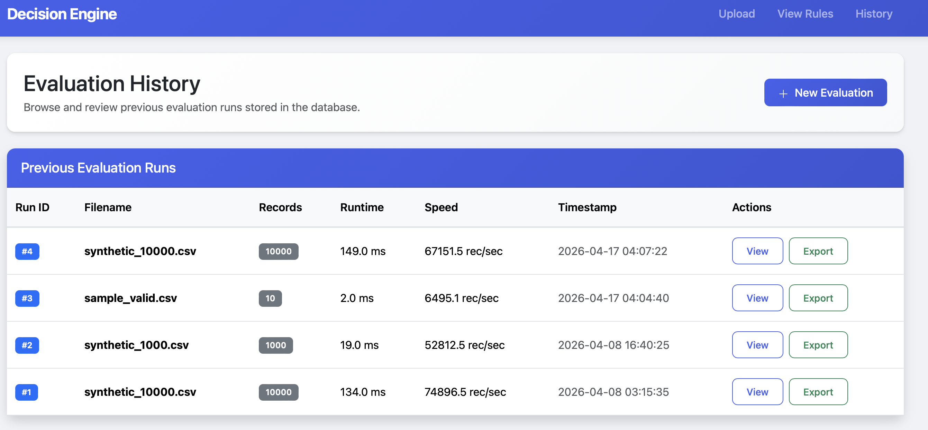
After Null Values file tested: 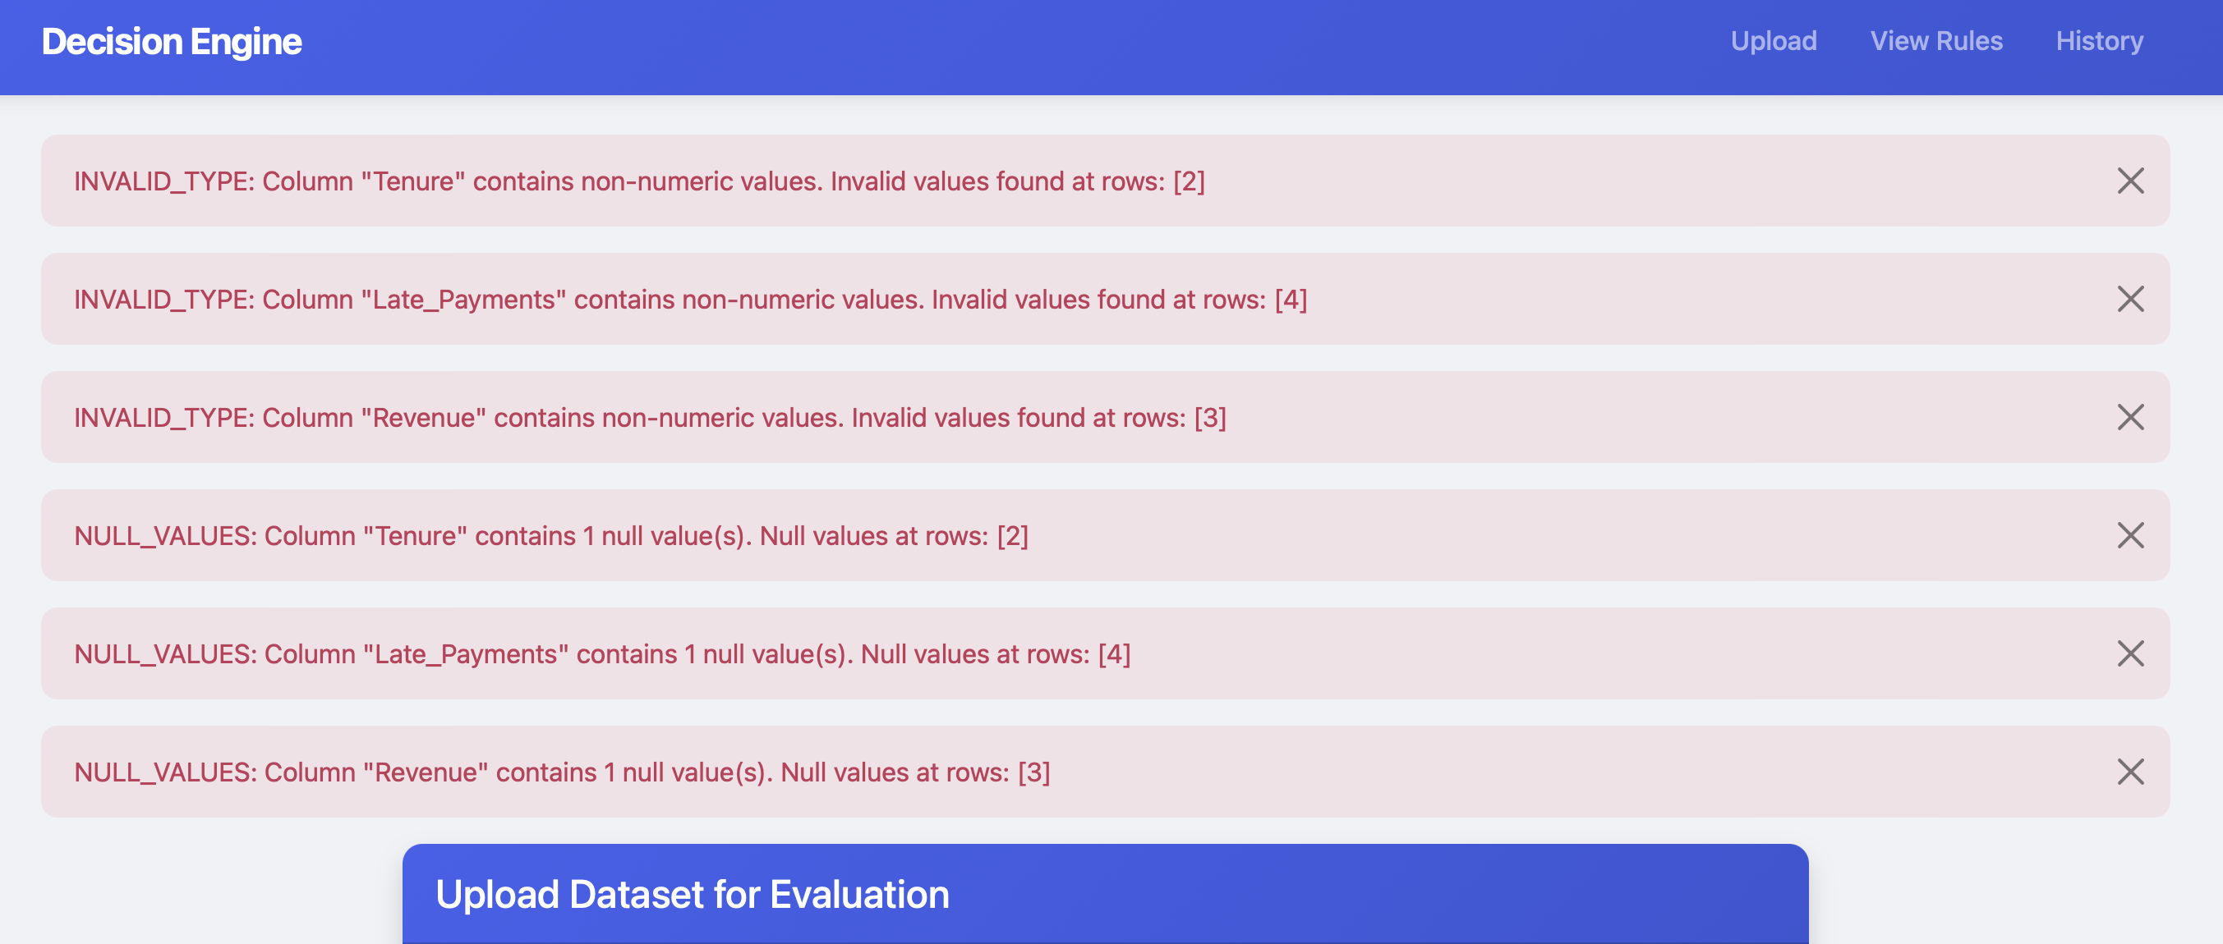
Missing Columns:
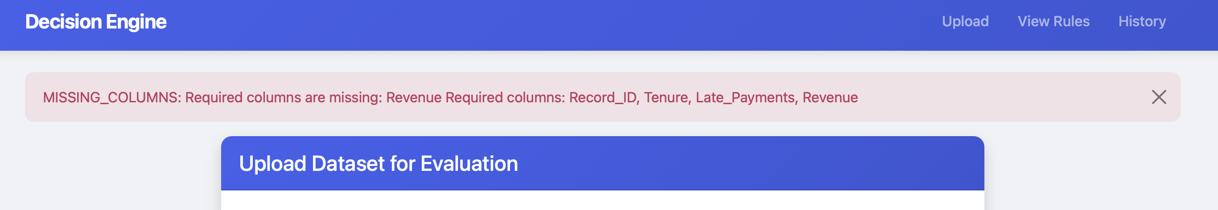
Refactored the code from a single large file into four separate modules. Each module has a single responsibility:
- validation.py handles input validation
- rules.py defines the decision rules
- engine.py does the scoring
- database.py handles persistence
This allows me to test each module independently.
Screenshot from code on next page.
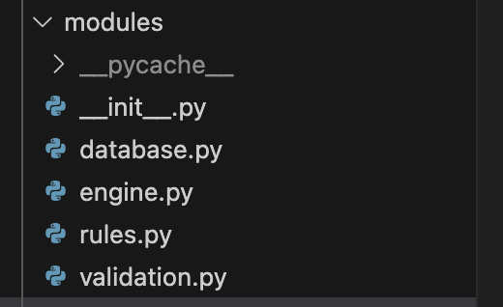
Documents updated (design doc, report, etc.):
- docs/FINAL_CHECKLIST.md - Complete verification checklist (NEW)
- docs/END_TO_END_TESTING.md - E2E test scenarios (NEW)
- docs/TESTING.md - Test execution guide (NEW)
- docs/REFACTORING_DEMO.md - Before/after code structure (NEW)
Other artifacts:
- 60 automated unit tests
- 3 synthetic test datasets
- Demo script prepared

Challenges or Roadblocks
What slowed you down or blocked progress?
- Database schema needed to be recreated after adding runtime metrics columns
- Ensuring all documentation is consistent and comprehensive
How you addressed it (or plan to):
Deleted old database to recreate with updated schema. Created standardized documentation templates for consistency across all docs.

What I Learned This Week
Technical, project management, or problem solving insights.
- End-to-end testing documentation helps identify edge cases that unit tests might miss
- A comprehensive verification checklist ensures nothing is overlooked before demo
- Good documentation takes significant time but greatly improves project quality

Plan for Next Week
Clear, actionable goals for the upcoming week. Refer to your developer work plan if necessary. Deviations are acceptable
- Deliver Checkpoint 3 presentation in class
- Complete any final Checkpoint 4 polish based on feedback
- Finalize repository for submission
- Prepare final demo rehearsal

Support Needed
Where you need feedback, clarification, or help.
- None at this time – All deliverables completed.

Time Spent on Capstone This Week
Hours worked: 14

